7.15.10.22 E-shop orders check

We are checking the availabilty of our products via this function.

Order: place sales order number
To: place the same order number
+ Next
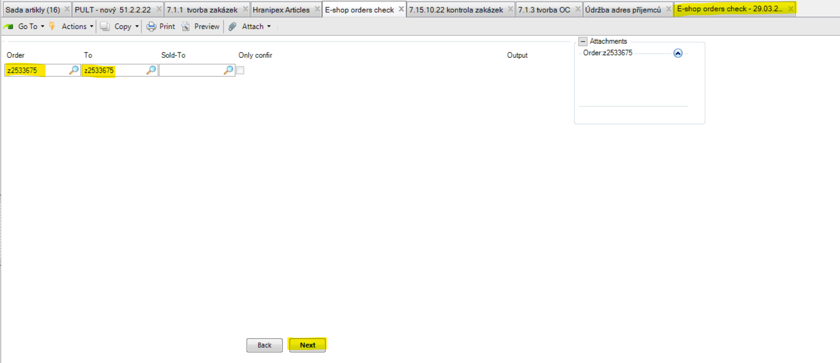

sales order z2533675:
If all items are in our stock, the report is empty. There are no item lines.

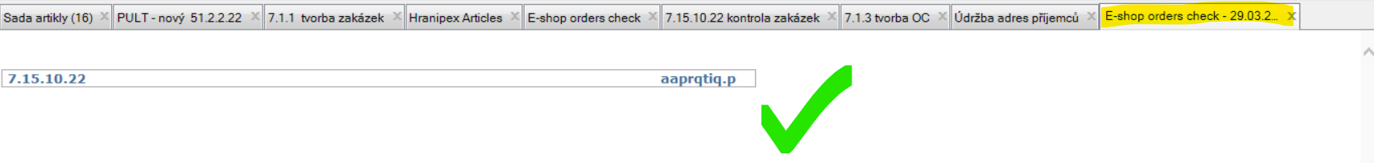

Notice:
When using 7.15.10.22 it always depends on from which domain you are checking the availability. The function displays information from particular domain + HRX CZ (HQ) domain 200.
E.g. to see what is your HRX NL (domain 1400) stock status versus HRX CZ (domain 200).
From your NL domain, it is a bit different view than from CZ domain.

sales order z2533147 / CZ domain 200:
position 8 = 30140XX00045033 (PG 2020 – melamine, stocked /collection) = there are JRs from we can slit (HRX CZ planner will arrange).
position 54 = 171047X10022080 (PG 1510 – HRX UNI color, atypical / extruded) = this is HRX atypical production based on a request, we have to produce this edge just for this particular order (HRX CZ planner will arrange).
position 68 = 75030024130 (PG 3530 – veneer, atypical / on request) = this is supplyied item based on a request, we have to purchase this edge from our supplier for this particular order (HRX CZ purchaser will arrange).
Below printscreen is what I see from our CZ domain 200 (HRX HQ).
Each item I´m checking in Hranipex Article function. Line, by line. This way is more comfortable from my point of view.
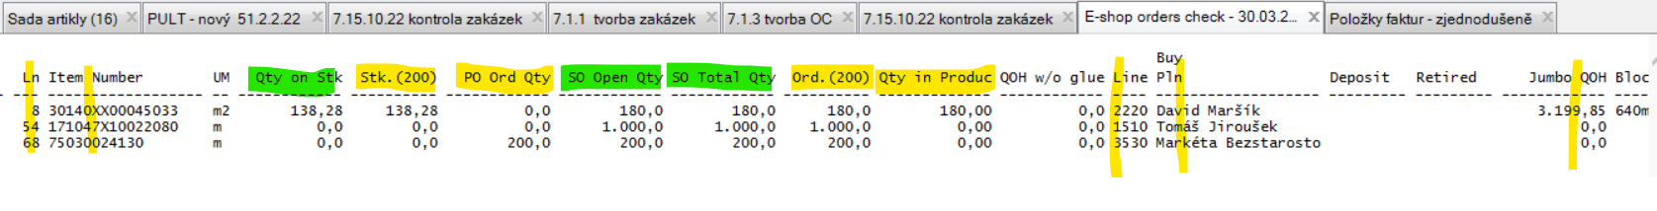
Ln: position
Item Number: article name
UM: unit of measure
Qty on Stk + Stk. (200): means what CZ (HQ) domain has in stock (the same value)
PO Ord Qty: means what is on Purchase orders in CZ domain (not HRX production, only supplied items)
SO Open Qty: means what is on the particular sales order z2533147 in CZ domain
So Total Qty + Ord. (200): means what is in total on all sales orders in CZ domain
Qty in Produc: means what is planned for a production in CZ domain
Line: Product Group (PG 1010, etc.)
Buy Pln: name of planner in HRX CZ (person responsible for planning of a production)
Jumbo QOH: jumbo rolls quantity on hand (this data is visible for our stocked JRs what we have in collection / JRs in PG 1210, 2020 = you can directly see how many m2 we have and from what amount we can slit a required dimension).
sales order K2305525 / DE domain 700 = article 10113XX00042050:
This is what you see from your NL domain (by using your own sales order number range).
Sold-To: customer number (buyer)
S. order: sales order number of particular branch
Purchase Order: purchase order number of branch´s customer
Ln: position
Item Number: article name
UM: unit of measure
Qty on stk: means what branch has in stock
STk. (200): means what CZ domain has in stock
PO Ord Qty: means what branch purchases from CZ
SO open Qty: means what is on the particular sales order K2305525 at branch
SO Total Qty: means what is in total on all sales orders at branch

For more information chec the article/s in Hranipex articles function. You get more details about the items here.

